**Sam Lazrak**

**CS 303 Algorithms and Data Structures**

**Homework Assignment 10**

**4/10/18**

1. **Work the following Exercises from Chapter 22 of the text:** 
   1. **(3 points) Exercise 22.1-2, page 592.**

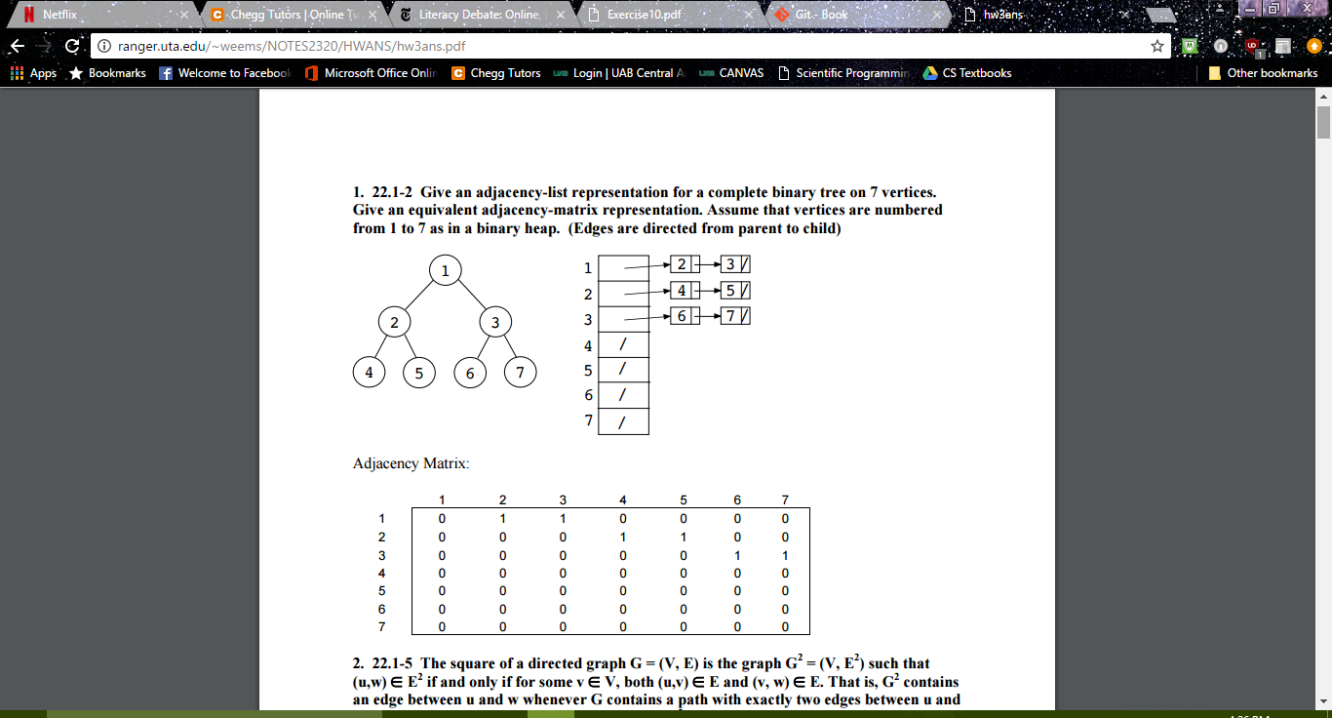

(<http://ranger.uta.edu/~weems/NOTES2320/HWANS/hw3ans.pdf>)

* 1. **(2 points) Exercise 22.2-2, page 601.**

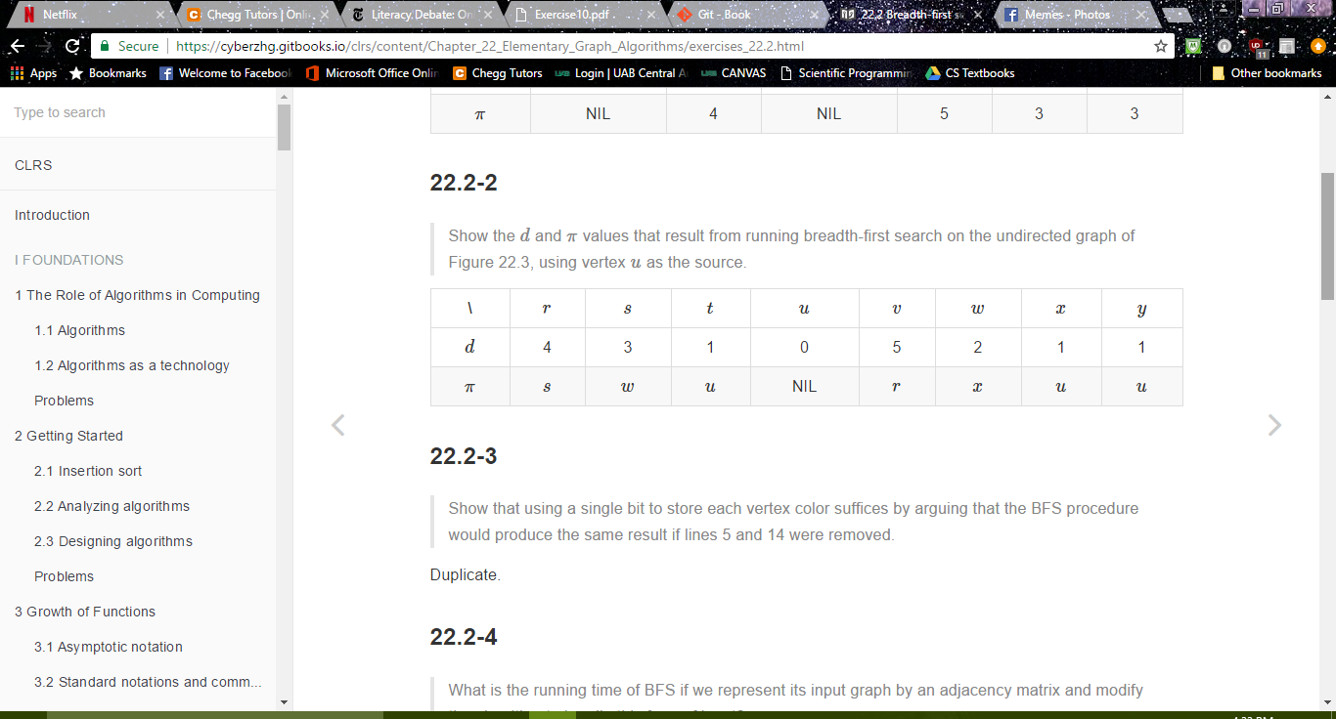

(<https://cyberzhg.gitbooks.io/clrs/content/Chapter_22_Elementary_Graph_Algorithms/exercises_22.2.html>)

* 1. 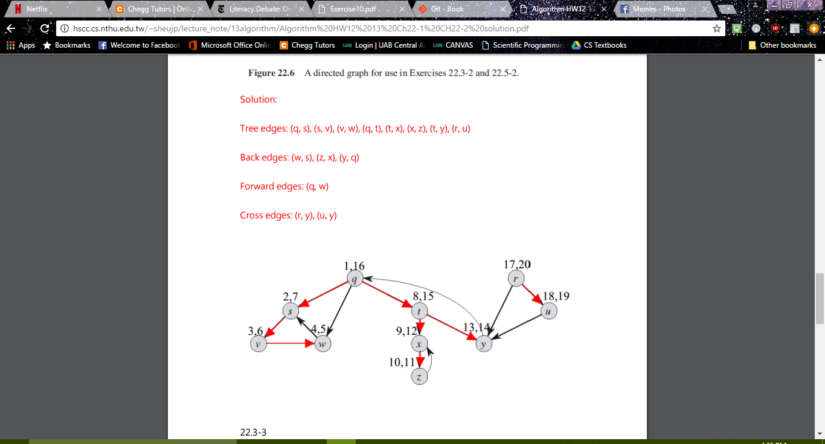**(2 points) Exercise 22.3-2, page 610.**

([http://hscc.cs.nthu.edu.tw/~sheujp/lecture_note/13algorithm/Algorithm%20HW12%2013%20Ch22-1%20CH22-2%20solution.pdf](http://hscc.cs.nthu.edu.tw/~sheujp/lecture_note/13algorithm/Algorithm%2520HW12%252013%2520Ch22-1%2520CH22-2%2520solution.pdf))

1. **Work the following Exercise from Chapter 22 of the text if desired for extra credit:** 
   1. **(2 points) Exercise 22.2-1, page 601.**

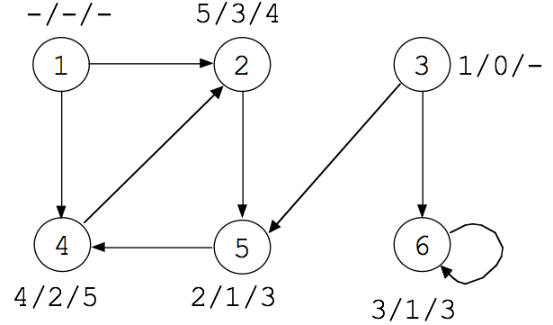

1. **Work the following Exercises from Chapter 23 of the text:** 
   1. **(3 points) Exercise 23.1-1, page 629.**

Let A be a subset of some MST T such that (u, v) Ï A. To choose an edge to be added to A, all the edges on the cut are considered and an edge with lowest weight is selected. Since (u, v) is the minimum weight edge in the graph G, it gets selected on some cut.

* 1. **(3 points) Exercise 23.1-3, page 629.**

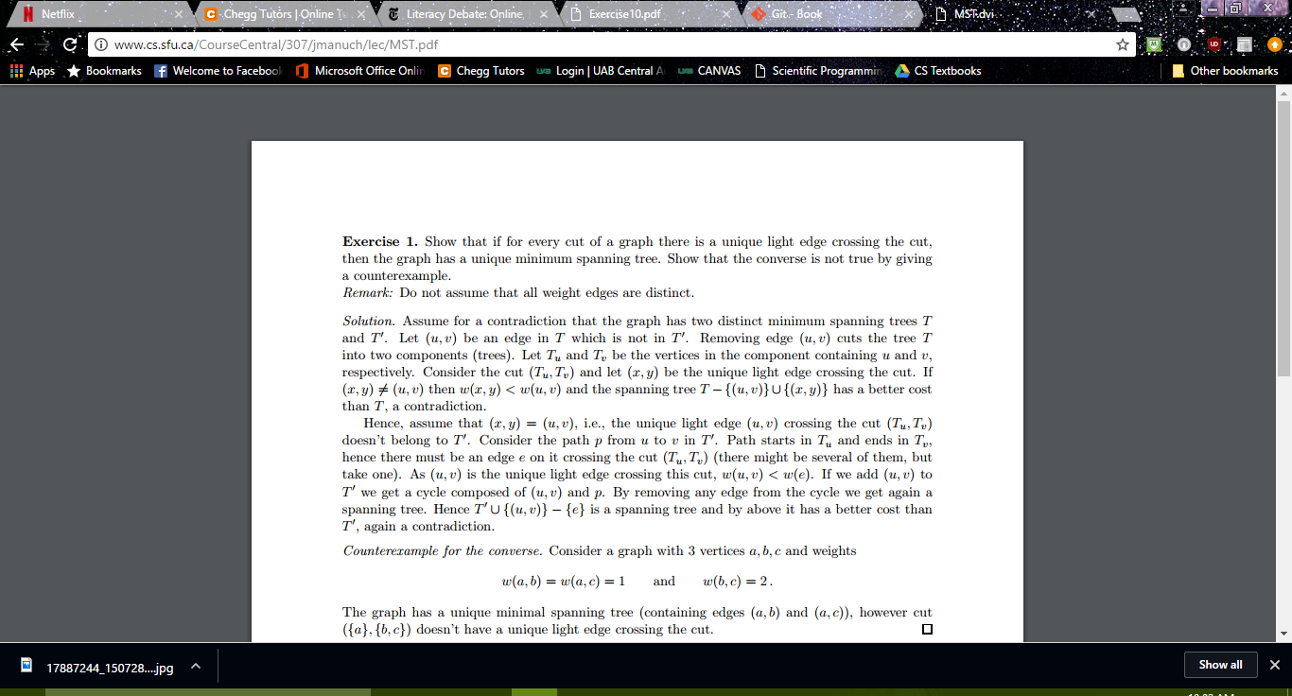

(<http://www.cs.sfu.ca/CourseCentral/307/jmanuch/lec/MST.pdf>)

* 1. **(3 points) Exercise 23.1-5, page 629.**

Let T be a minimum spanning tree of G'. Then T is also a spanning tree of G since G' and G contain the same vertices. Suppose T is not a minimum spanning tree. The only difference between G and G' is the edge e. So if T is not a minimum spanning tree of G then there must be a tree T' in G that is a minimum spanning tree with weight less than T and containing the edge e. But e is a maximum edge on a cycle. So remove the edge e from T' and add an edge (x,y) from the cycle that is not already in T' to make T''. T'' must be a tree with weight less than T' since the edge (x,y) has weight less than e (since e is maximum). But then T' is not a minimum spanning tree, a contradiction.

(<http://ramos.elo.utfsm.cl/~lsb/elo320/aplicaciones/aplicaciones/CS460AlgorithmsandComplexity/lecture12/problems.htm>)

* 1. 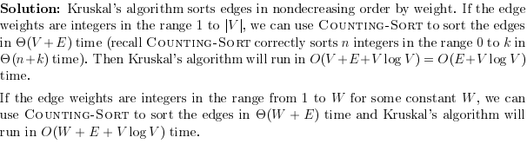**(3 points) Exercise 23.2-4, page 637.**

([http://s3.alirezaweb.com/91-5/introduction-to-algorithms/solution-manual/CLRS-Exercises-Introduction-to-Algorithms_Borna66/CLRS-Introduction-to-Algorithms/H20-solution[www.alirezaweb.com].pdf](http://s3.alirezaweb.com/91-5/introduction-to-algorithms/solution-manual/CLRS-Exercises-Introduction-to-Algorithms_Borna66/CLRS-Introduction-to-Algorithms/H20-solution%255bwww.alirezaweb.com%255d.pdf))

1. **Work the following Exercise from Chapter 23 of the text if desired for extra credit:** 
   1. **(6 points) Exercise 23.2-5, page 637.**

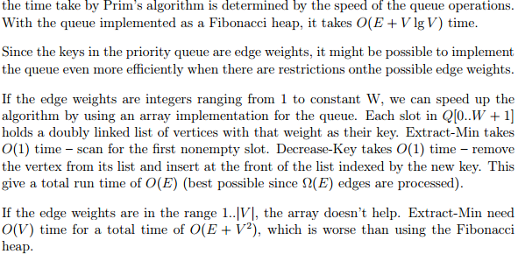(<http://cs.txstate.edu/~ch04/webtest/teaching/courses/5329/homework/solutions/ch23.pdf>)

1. **Work the following Exercises from Chapter 24 of the text:** 
   1. **(3 points) Exercise 24.1-1, page 654.**

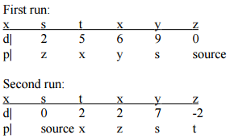

(<http://mkcomp510.weebly.com/uploads/1/3/4/6/13461332/kaisercomp510assignment7.pdf>)

* 1. 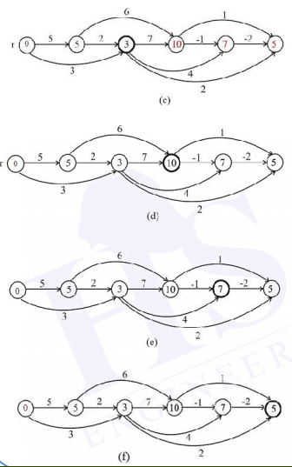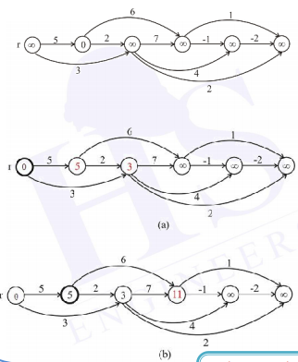**(3 points) Exercise 24.2-1, page 657.**

(<http://www.eng-hs.net/files/Algorithms-Sol-CH-24.pdf>)

* 1. **(3 points) Exercise 24.3-1, page 662.**

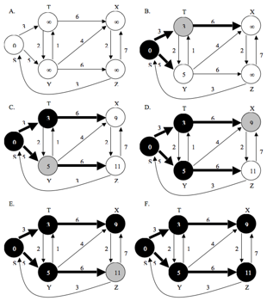

(<https://github.com/gzc/CLRS/blob/master/C24-Single-Source-Shortest-Paths/repo/s3/1.png>)

* 1. **(3 points) Exercise 24.3-6, page 663.**

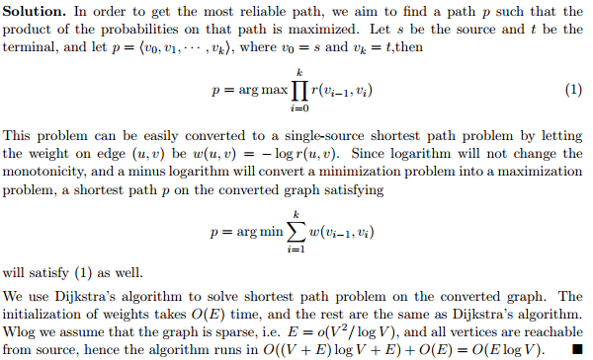**Note carefully that in the statement of the problem, an edge weight r(u, v) = 1 is the highest reliability circuit and a r(u, v) = 0 is the least reliable. The problem is to find highly reliable paths between two given vertices.**

(<http://cs.jhu.edu/~cs363/fall2013/assign8_sln.pdf>)